|  |
| --- |
|  |
| Org Portal WinRT |
| Wireframes Final |
|  |
| **Jerry Falconer** |
| **2/26/2014** |

* 1. User Home

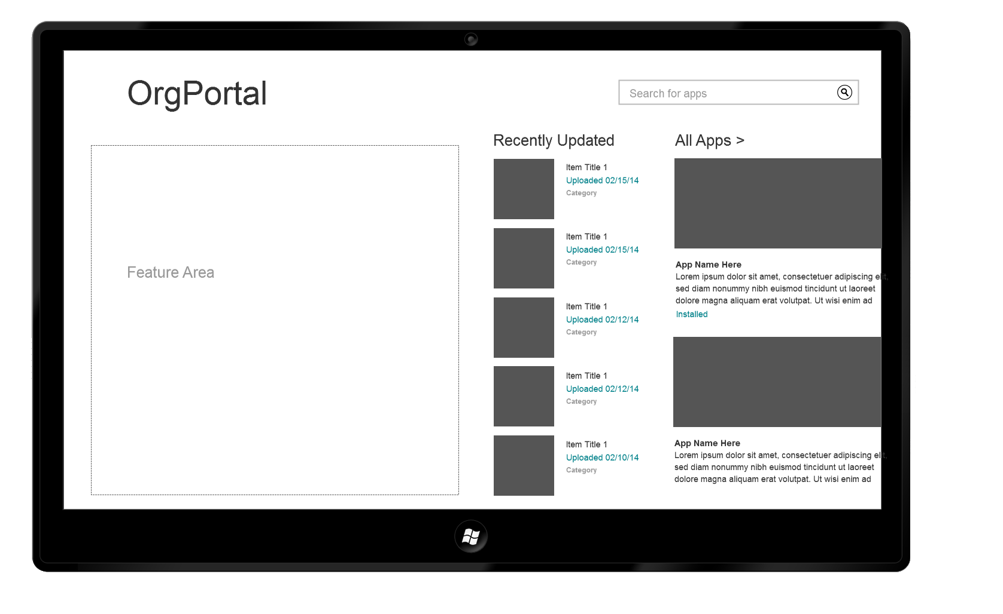

* 1. Menu

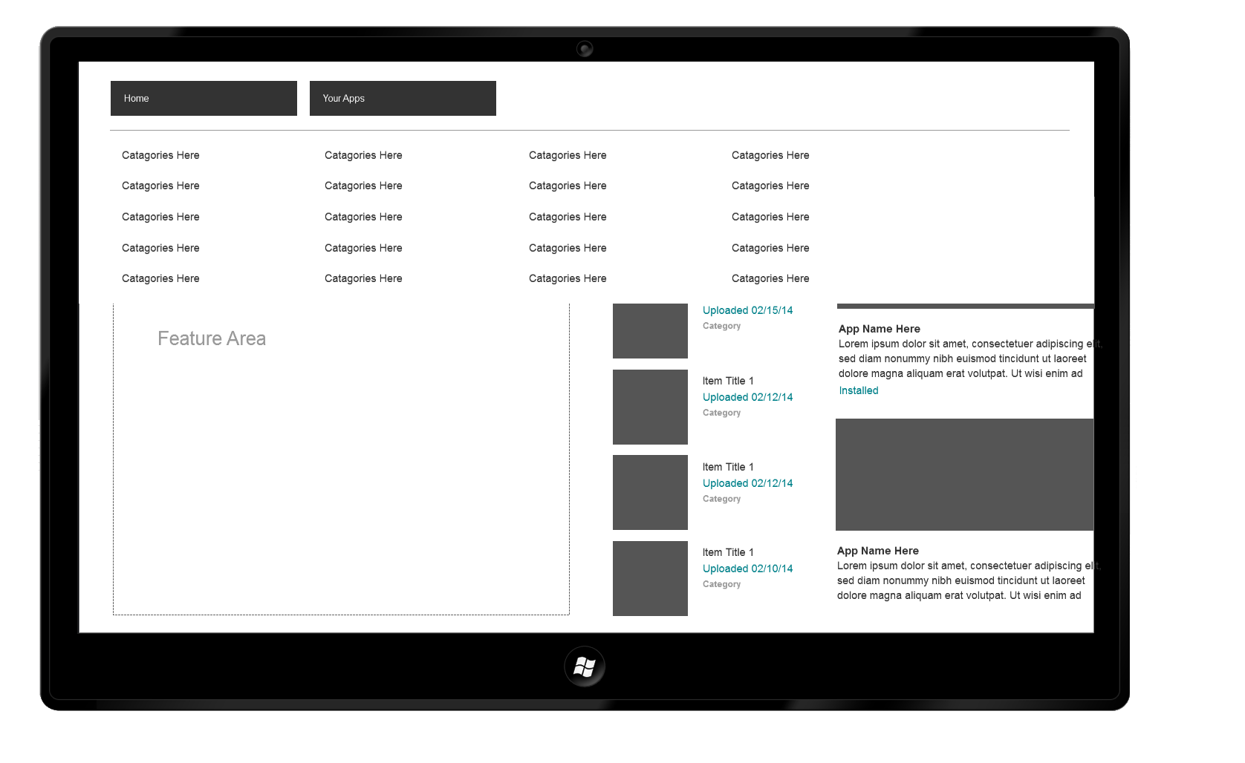

* 1. Home Scroll Vertical

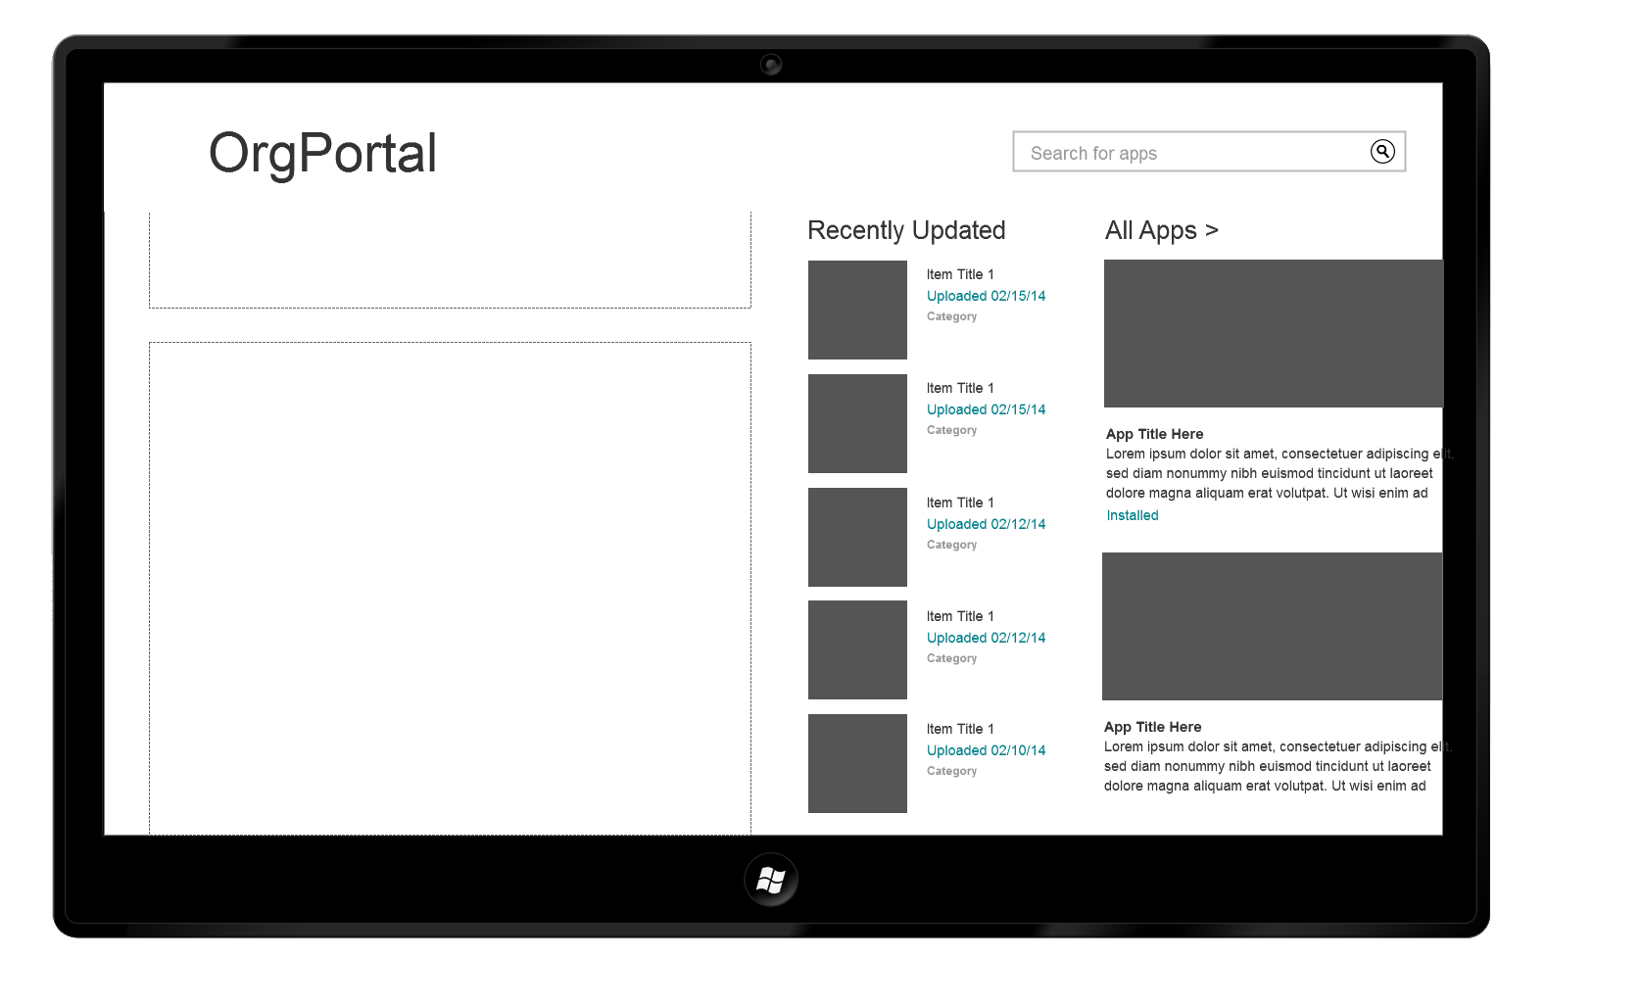

* 1. Home Scroll Right

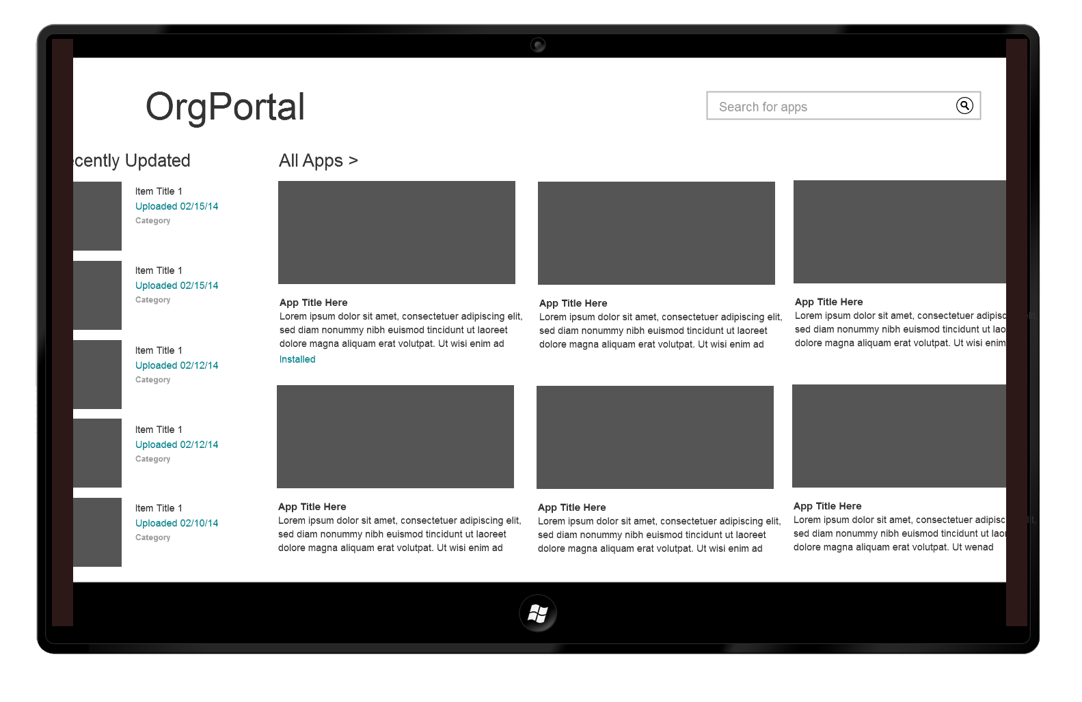

* 1. Your Apps

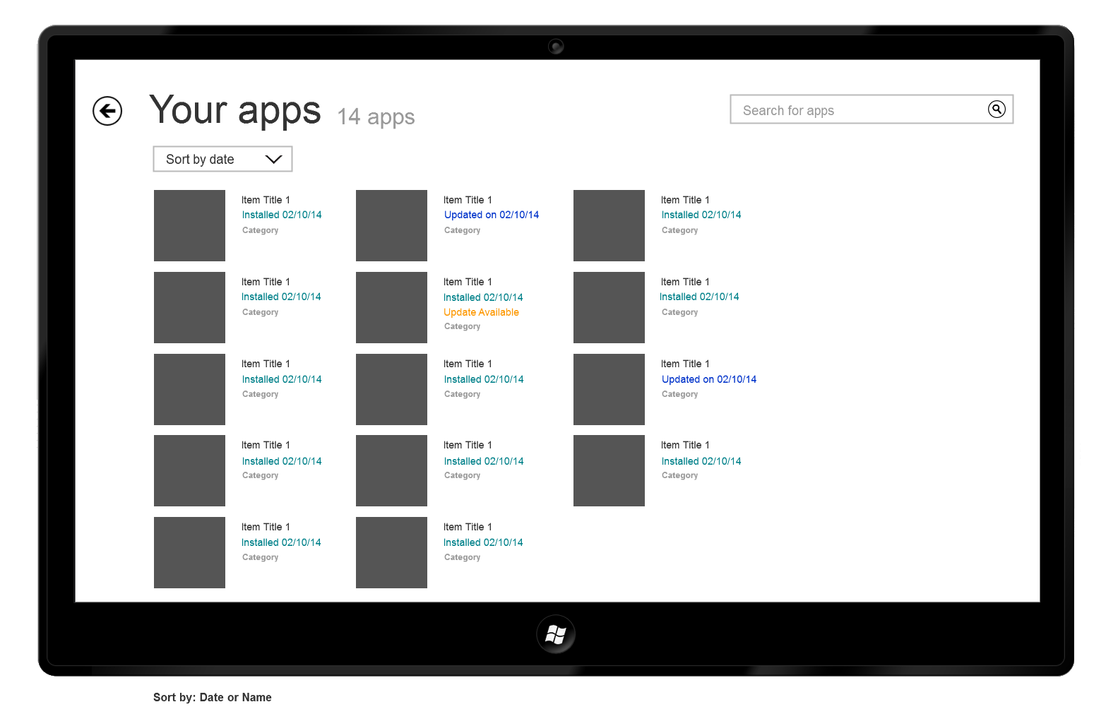

* 1. Category

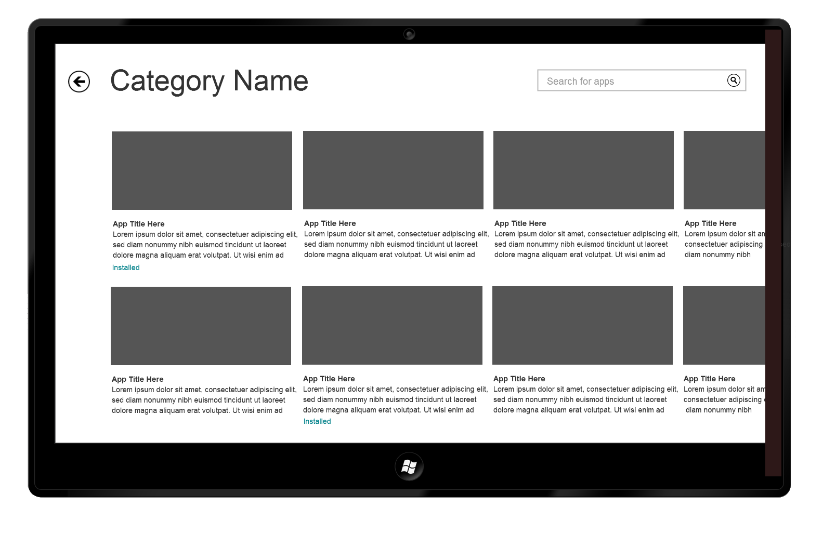

* 1. App Home

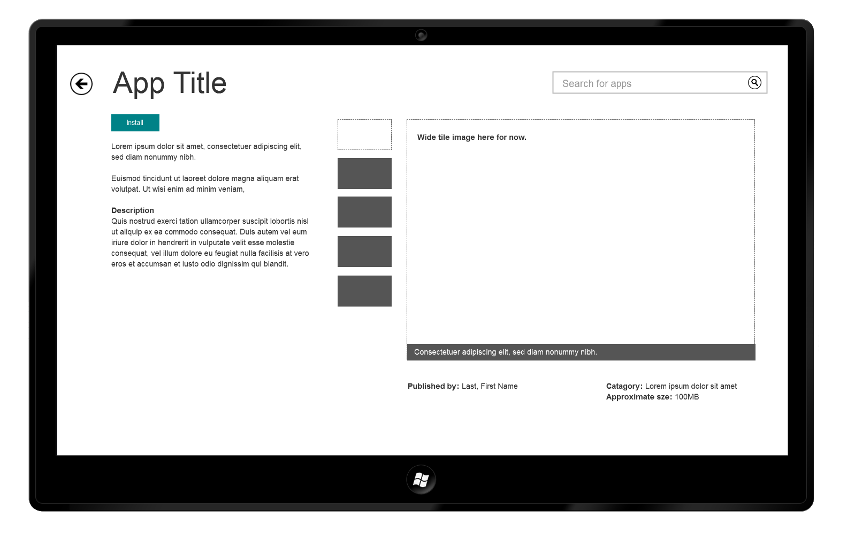

* 1. Installing

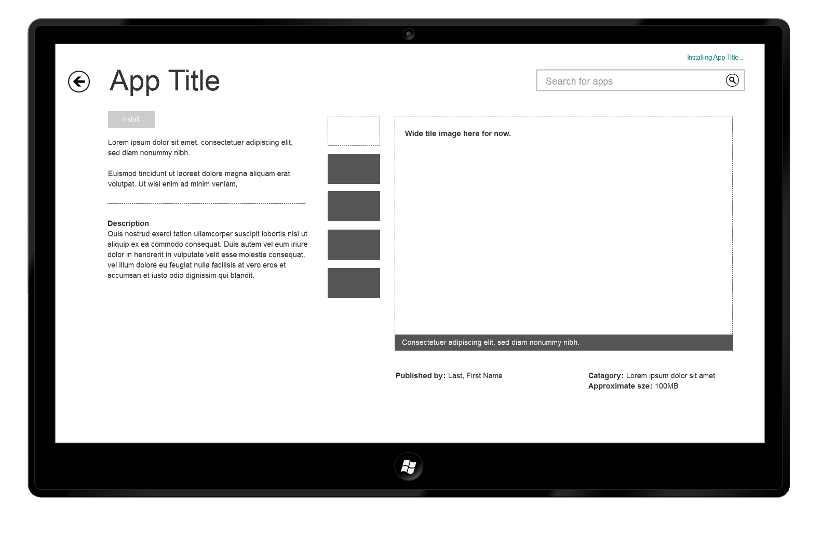

* 1. Installed

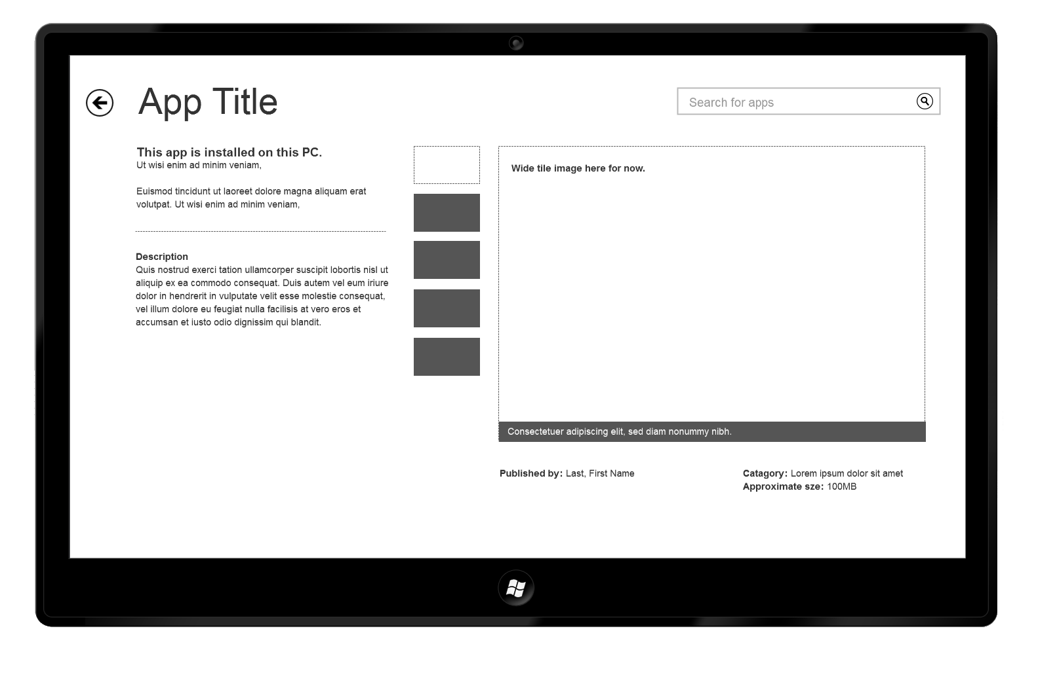

* 1. Update Version

